Friday 28th May 2021

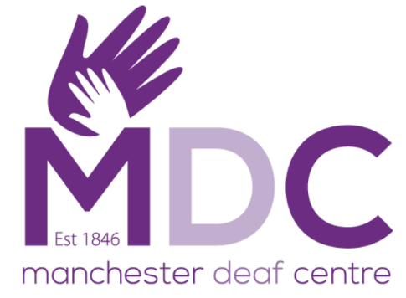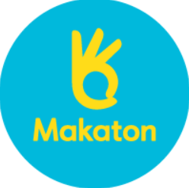

Dear Parents/Carers,

On **Friday 11th June 2021** we will be taking part in the Manchester Deaf Centre Awareness Day.

**We will be having a non-uniform** **day** with a **PURPLE** and **BLUE** theme.

As part of the day, the children will be doing fun activities linked to Makaton and learning more about how they can support and communicate with people who have hearing and communication difficulties. We hope you can help support us in making Manchester Deaf Centre Awareness Day lots of fun for the children and help raise awareness for a great cause.

Yours Sincerely

Varna Staff