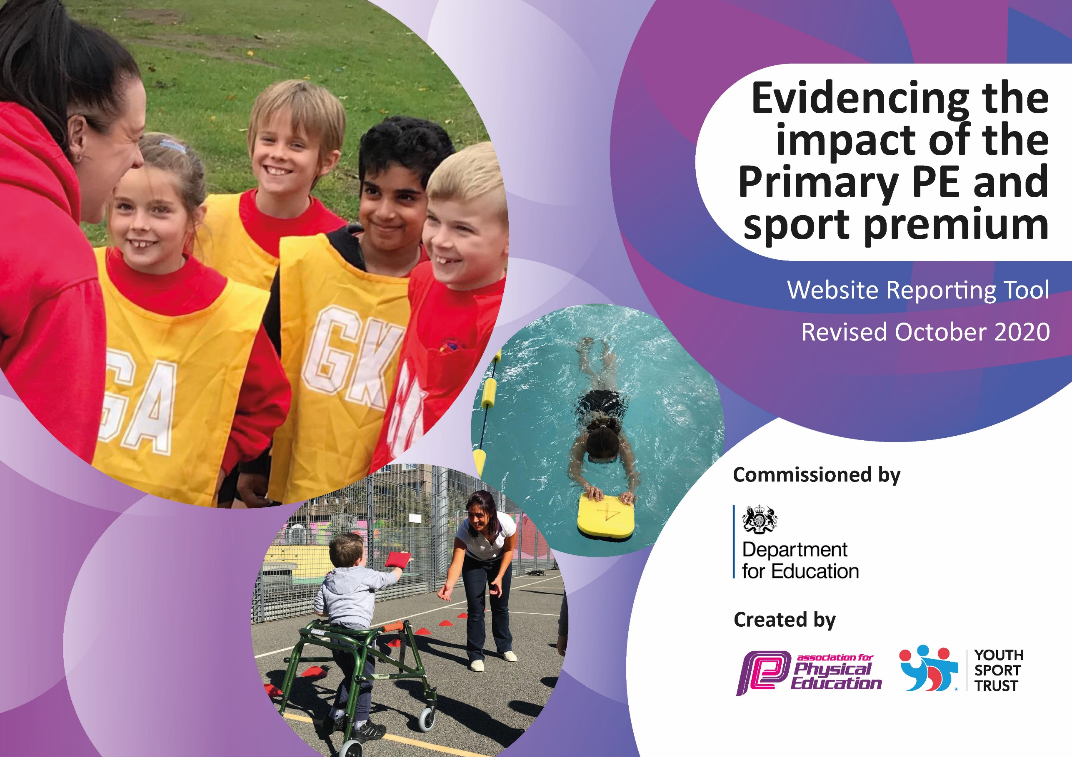
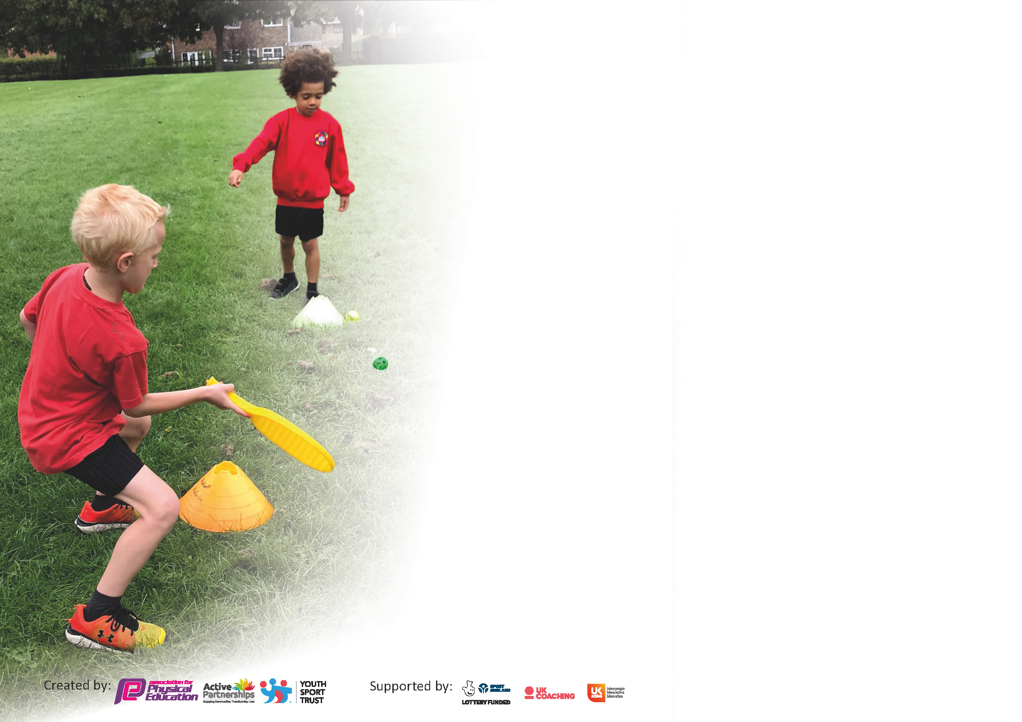

It is important that your grant is used effectively and based on school need. The Education Inspection Framework (Ofsted 2019 p64) makes clear there will be a focus on ‘whether leaders and those responsible for governors all understand their respective roles and perform these in a way that enhances the effectiveness of the school’.

Under the Quality of Education criteria (p41) inspectors consider the extent to which schools can articulate their curriculum (INTENT), construct their curriculum (IMPLEMENTATION) and demonstrate the outcomes which result (IMPACT).

To assist schools with common transferable language this template has been developed to utilise the same three headings which should make your plans easily transferable between working documents.

Schools must use the funding to make additional and sustainable improvements to the quality of Physical Education, School Sport and Physical Activity (PESSPA) they offer. This means that you should use
the Primary PE and sport premium to:

- Develop or add to the PESSPA activities that your school already offer
- Build capacity and capability within the school to ensure that improvements made now will benefit pupils joining the school in future years

Please visit gov.uk for the revised DfE guidance including the 5 key indicators across which schools should demonstrate an improvement. This document will help you to review your
provision and to report your spend. DfE encourages schools to use this template as an effective way of meeting the reporting requirements of the Primary PE and sport premium.

We recommend you start by reflecting on the impact of current provision and reviewing the previous spend.

Schools are required to publish details of how they spend this funding as well as on the impact it has on pupils’ PE and sport participation and attainment by the end of the summer term or by 31st July 2021 at the latest.

** In the case of any under-spend from 2019/20 which has been carried over this must be used and published by 31st March 2021.

We recommend regularly updating the table and publishing it on your website throughout the year. This evidences your ongoing self-evaluation of how you are using the funding to secure maximum, sustainable impact. Final copy must
be posted on your website by the end of the academic year and no later than the 31st July 2021. To see an example of how to complete the table please click HERE.
Created by: Supported by:

Please note: Although there has been considerable disruption in 2020 it is important that you publish details on your website of how you spend the funding - this is a legal requirement.
Support for review and reflection - considering the 5 key indicators from DfE, what development needs are a priority for your setting and your pupils now and why? Use the space below to reflect on previous spend and key achievements and areas for development.

N.B. In this section you should refer to any adjustments you might have made due to Covid-19 and how these will influence further improvement.
Key achievements to date until July 2020: | Areas for further improvement and baseline evidence of need:
A broader range of after school clubs. As of Spring 2020, the clubs that we offered the children were:  Football, basketball, netball, table tennis, cheerleading, multi-sports.  These activities were chosen through pupil voice.  Dance CPD sessions began for KS1 &2. Alicia Graham led a staff meeting with all teachers from KS1&2. PE co-ordinator worked alongside Alicia to develop a planning format that met the needs for Varna. Alicia then worked alongside year 2,3 and year 6, supporting with the planning and delivery of lessons. Themes were chosen based on each year group’s topic focus.  EYFS were working with City Play as CPD  Started Runability to raise profile of sports. Confidence levels were assessed for all children across the school in order to identify children who many need more support. These planned workshops following this could not take place due to school closures. | Continue with Dance CPD. These sessions were postponed last year due to school closures. Dance CPD will recommence in Summer 2.  Swimming sessions for Year 5 to make up for the term and a half they missed due to COVID. These swimming sessions were due to start in Spring 1, however due to pool closures they were unable to take place. The sessions will now begin w/c 19/4/2021  Invest in a scheme of work for outdoor games that staff can deliver safely under COVID guidance. Sports coaches are employed to teach outdoor games, therefore, staff will need planning and clear guidance in how best to run these sessions safely and productively. PE co-ordinator will conduct training on the app and assessment. PE co-ordinator will also model sessions.  Invest in more outdoor games equipment so that all bubbles can participate in sports adhering to COVID guidance. Each bubble must have their own equipment. A new playground format will be set up to encourage children to participate in a wider variety of games.  Invest in more outdoor play equipment for EYFS

Did you carry forward an underspend from 2019-20 academic year into the current academic year? YES
If any funding from the academic year 2019/20 has been carried over you MUST complete the following section. Any carried over funding MUST be spent by 31 March 2021.
Academic Year: September 2020 to March 2021 | Total fund carried over: £6151.92 | Date Updated: November 2020
What Key indicator(s) are you going to focus on? Key indicator 4: Broader experience of a range of sports and activities offered to all pupils |  |  |  | Total Carry Over Funding:
 |  |  |  | £6151.92
Intent | Implementation |  | Impact
Your school focus should be clear how you want to impact on your pupils.  Invest in a new PE scheme for outdoor games that staff can lead adhering to social distancing  Purchase PE equipment for individual bubbles to use to adhere to COVID guidance  Purchase outdoor equipment for EYFS to allow more engagement in continuous provision and promote outdoor activities, adhering with COVID guidance | Make sure your actions to achieve are linked to your intentions:  Trial PPP with less confident staff members  Review with children to assess engagement and enjoyment  Plan out curriculum content across year groups  Audit what stock we already have  Order storage equipment  Order enough equipment for each individual bubble to use at break/lunchtime | Carry over funding allocated:  £700  £2951  £2500 | Evidence of impact: How can you measure the impact on your pupils; you may have focussed on the difference that PE, SS & PA have made to pupils re-engagement with school. What has changed?  App was purchased in Autumn 2.  Staff have been trained in using the APP.  Pupil/Staff voice to be conducted in Spring 2 in regards to confidence and engagement.  Outdoor games equipment has been purchased to ensure the children receive opportunities to experience a variety of sports.  Pupil voice to be taken at the end of the year to identify which sports were enjoyed and which may need to be adapted to increase engagement. | Sustainability and suggested next steps and how does this link with the key indicators on which you are focussing this academic year?:  Staff will recieve CPD in all areas of the PE curriculum to ensure they are confident in planning and delivering gymnastics, dance and games.

Meeting national curriculum requirements for swimming and water safety.

N.B Complete this section to your best ability. For example you might have practised safe self-rescue techniques on dry land.
What percentage of your current Year 6 cohort swim competently, confidently and proficiently over a distance of at least 25 metres?  N.B. Even though your pupils may swim in another year please report on their attainment on leaving primary school at the end of the summer term 2020. | 80%
What percentage of your current Year 6 cohort use a range of strokes effectively [for example, front crawl, backstroke and breaststroke]? | 59%
What percentage of your current Year 6 cohort perform safe self-rescue in different water-based situations? | 72%
Schools can choose to use the Primary PE and sport premium to provide additional provision for swimming but this must be for activity over and above the national curriculum requirements. Have you used it in this way? | No

Action Plan and Budget Tracking
Capture your intended annual spend against the 5 key indicators. Clarify the success criteria and evidence of impact that you intend to measure to evaluate for pupils today and for the future.

Academic Year: 2020/21 | Total fund allocated: £19570 | Date Updated: November 2020
Key indicator 1: The engagement of all pupils in regular physical activity – Chief Medical Officers guidelines recommend that primary school pupils undertake at least 30 minutes of physical activity a day in school |  |  |  | Percentage of total allocation:
Intent | Implementation |  | Impact
Your school focus should be clear what you want the pupils to know and be able to do and about  what they need to learn and to  consolidate through practice: | Make sure your actions to achieve are linked to your intentions: | Funding allocated: | Evidence of impact: what do pupils now know and what can they now do? What has changed?: | Sustainability and suggested next steps:
Introduce the Daily Mile to KS1&2  Purchase break/lunchtime equipment for each bubble to use adhering to COVID guidance | - Map out a mile to run  - Provide staff with a map of the route  - Introduce to the children  - Promote across the school  - Encourage a range of challenges to engage all children  - PL to monitor daily miles to ensure being led consistently across the school  Audit break/lunchtime resources  Separate areas into zones  Purchase equipment for each zone  Create a rota for TA’s allocating a different zone each week so children can have access to a range of activities across the half term | £0  £2000 | The daily mile began in Autumn 2 with children participating in the daily mile 3x weekly (not on PE days).  This was incorporated into our sponsored walk, where the children were asked to complete challenges on each lap. Personal best/challenges will be set from Summer 2 to encourage full engagement.  Children participate in the daily mile on the days when they do not have a PE lesson to ensure they are exceeding their 30 active minutes each day. Children’s stamina has improved and the activity is being used as an opportunity to develop leadership and team work skills through allocating pace setters.  Equipment purchased for all zones. Children are now participating in a range of activities that they would not have chosen to do before.  TA’s have been trained by the PE lead to deliver active activities in each of the zones, with a focus on personal best, team building and developing new skills. | Daily Mile to be a main focus during the next academic year.  Adults are to become leaders of smaller groups in order to promote personal best  Equipment purchased for each zone – TA’s to receive training to support the children during the next academic year

Key indicator 2: The profile of PESSPA being raised across the school as a tool for whole school improvement
Intent | Implementation |  | Impact
Your school focus should be clear what you want the pupils to know and be able to do and about  what they need to learn and to  consolidate through practice: | Make sure your actions to achieve are linked to your intentions: | Funding allocated: | Evidence of impact: what do pupils now know and what can they now do? What has changed?: | Sustainability and suggested next steps:
Apply for School games bronze mark  Purchase a wider range of PE equipment for outdoor games | - Audit pe provision  - Collate staff voice in regards to current PESSPA provision  - Collate pupil voice in regards to current PESSPA provision  - Set internal challenges across the school (challenge zone built into playground areas)  - Purchase provisions for challenge areas  - Adapt the long term plan for outdoor games that ensure each key stage children are experiencing a wider variety of outdoor games | £2000  Postponed due to COVID  £780 | This has now been postponed to academic year 2021/22 as School Games have confirmed they will not be completing applications this year.  PE equipment purchased for children to use in 2021/22 A range of sports have been catered for to ensure a wider number of games can be experienced | Subject Lead to apply for School Games Award during the next application process  SL to continue gathering pupil voice in order to tailor the games offered within school to the children’s requests

Key indicator 3: Increased confidence, knowledge and skills of all staff in teaching PE and sport
Intent | Implementation |  | Impact
Your school focus should be clear | Make sure your actions to | Funding | Evidence of impact: what do | Sustainability and suggested
what you want the pupils to know | achieve are linked to your | allocated: | pupils now know and what | next steps:
and be able to do and about | intentions: |  | can they now do? What has
what they need to learn and to |  |  | changed?:
consolidate through practice:
City in the Community CPD  PE Coordinator Training MPETT  PE leadership course  Research and purchase Dance CPD for Years 1,2,3,6 (years 4&5 to attend swimming sessions) | Yearly contract with Cityplay for EYFS CPD.  1 coach to work with staff member 1:1, demonstrating and supporting teacher with outdoor games.  HL to gather staff voice at start and end of year to determine impact  Cityplay to provide assessment of learning for children termly  3 x virtual meetings a year.  SD provided with time to attend  -1 x virtual meeting looking at developing the PE curriculum  Dance CPD to resume in summer 2 for 5 weeks. This will be continued into the Autumn term.  Staff voice to be collected beforehand  Meetings with Alicia Graham to develop planning, ensuring progression of skills are clear.  -Terminology and retrieval to be identified in planning  -Ensure reflects the 4 Me’s to be consistent across the full PE curriculum | £1250  £195  £150  £1375 | Staff took part in CPD training for all of Autumn term. The CPD was paused during Spring 1 and part of Spring 2. CPD sessions resumed w/c 8/3/202.  All staff have now received training from CityPlay and have expressed that they feel confident in delivering PA within the EYFS setting  2 x meetings have taken place virtually. Discussion was based around lockdown procedures with guidance for implementing PE safely.  3rd session took place in summer term, with ideas shared in supporting SEND children and developing the vocabulary used within PE lessons. This will form the basis of the new planning format ready for the new academic year.  Resources were shared and have been adapted to support the planning and assessment of PE by the coordinator. This has helped to underpin the skills progression documents and end of year statements.  Dance CPD due to commence in Spring term, however due to school closures, the CPD has been postponed to Summer 2. The dance CPD will be continued into the Autumn term.  In Summer 2, Dance CPD began for Years 2&6. Teachers were guided through planning units of work and assessing accurately. | EYFS PE lead to continue monitoring the provision of PA and PE within EYFS, with regular drop-in sessions and feedback meetings with staff to ensure continuous good practise.  Subject Lead to continue to attend meetings and develop a cluster group to share good practise with  Subject lead to continue to use the suggested framework to keep reviewing the current PE provision in order to provide quality experiences that reflect our children and their needs  Dance CPD is to continue for all other Year groups, with years 2 and 6 being monitored for their first self-planned unit by the subject lead.

Key indicator 4: Broader experience of a range of sports and activities offered to all pupils
Intent | Implementation |  | Impact
Your school focus should be clear | Make sure your actions to | Funding | Evidence of impact: what do | Sustainability and suggested
what you want the pupils to know | achieve are linked to your | allocated: | pupils now know and what | next steps:
and be able to do and about | intentions: |  | can they now do? What has
what they need to learn and to |  |  | changed?:
consolidate through practice:
Additional achievements:  Purchase swimming hats for all children attending swimming sessions to ensure resources are not shared  Extra swimming sessions for Year 5 pupils as they did not complete their swimming year  Debdale Water Sports Centre - Children to experience local sports amenities to develop new skills and build life-long interests/hobbies | - 60 children attending swimming sessions  - Purchase adult size hats to ensure it fits in all hair.  - Contact Lyndsey Linguard for extra sessions  - Risk assessment to be completed  - New staff members to pre-visit  - Letters to go out to parents  - Pupil voice to determine confidence before sessions begin and at the end of the year.  Years 3, 4 and 5 to visit Debdale Water Sports Centre for 1 visit per class | £250  £2000  £2700 | All year 5 children to be bought swimming hats so all children can participate in swimming sessions.  Catch up swimming sessions due to start every Tuesday in Spring 1, however due to pool closures this has been delayed. The new start date will be w/c April 19th.  All year 5 pupils receive one term of catch up swimming.  As Year 6 missed out on their residential trip, both classes partook in two trips to Debdale Water Sports Centre, where they were able to develop their teambuilding skills and resilience. From this experience, 13 children revisited the centre to engage in more of the activities there | Subject Lead to identify any children who have still not met the 3 NC standards and to target through the government funded free swimming sessions during holidays and half terms  Subject Lead t plan in the opportunity for all KS2 year groups to attend Debdale Water Sports Centre across the year in order to experience new activities, and to signpost any sessions available to them outside of school

Key indicator 5: Increased participation in competitive sport
Intent | Implementation |  | Impact
Your school focus should be clear | Make sure your actions to | Funding | Evidence of impact: what do | Sustainability and suggested
what you want the pupils to know | achieve are linked to your | allocated: | pupils now know and what | next steps:
and be able to do and about | intentions: |  | can they now do? What has
what they need to learn and to |  |  | changed?:
consolidate through practice:
Coaches for after school clubs – separating into year group bubbles  Equipment and resources purchased for Olympic themed Sports Day | 2 x coaches needed 4 x a week  1 session per each year group 3-6 to avoid mixing bubbles  Create a rota for different activities to participate in across the Summer to ensure each group has access to a range of internal competitions.  -Pupil voice which activities the children would like to compete in  -Develop a year 6 team sports leaders group to help set up equipment and guide teachers/children around the course  -Plan opportunities for staff and children to practice the activities, recording results to encourage personal best | £3200  Cancelled due to COVID  £300 | Coaches initially booked in for Spring term, however due to COVID guidance, the start date has had to be postponed.  All children partook in a competitive sports day, engaging in team sports and developing a sense of resilience | Competitions to resume in 2021/22.  Varna to hold competitions if COVID guidance allows.  Children were engaged in the week long themed activities based around the Olympics, which has led to more suggestions for more themed dates

