Pupil premium strategy statement 2023-2024

This statement details our school’s use of pupil premium (and recovery premium for the 2022 to 2023 academic year) funding to help improve the attainment of our disadvantaged pupils.

It outlines our pupil premium strategy, how we intend to spend the funding in this academic year and the effect that last year’s spending of pupil premium had within our school.

School overview
Detail | Data
School name | Varna Community Primary School
Number of pupils in school | 473 (28.11.23)
Proportion (%) of pupil premium eligible pupils | 48% (28.11.23)
Academic year/years that our current pupil premium strategy plan covers | 2023-2024
Date this statement was published | December 2023
Date on which it will be reviewed | September 2024
Statement authorised by | Karen Livesey/Peter Stone
Pupil premium lead | R. Crossley
Governor / Trustee lead | N. Goddard
Funding overview
Detail | Amount
Pupil premium funding allocation this academic year | £286,635
Recovery premium funding allocation this academic year | £29,000
Pupil premium funding carried forward from previous years (enter £0 if not applicable) | £0
Total budget for this academic year  If your school is an academy in a trust that pools this funding, state the amount available to your school this academic year | £315,635

Part A: Pupil premium strategy plan

Statement of intent
When making decisions about using Pupil Premium funding it is important to consider the context of the school and the subsequent challenges faced. This alongside research conducted by the EEF. Common barriers to learning for disadvantaged children can be: less support at home, weak language and communication skills, lack of confidence, more frequent behaviour difficulties and attendance and punctuality issues. There may also be complex family situations that prevent children from flourishing. The challenges are varied and there is no “one size fits all”.
We will ensure that all teaching staff are involved in the analysis of data and identification of pupils, so that they are fully aware of strengths and weaknesses across the school.
Principles
• We ensure that teaching and learning opportunities meet the needs of all the pupils
• We ensure that appropriate provision is made for pupils who belong to vulnerable groups, this includes ensuring that the needs of socially disadvantaged pupils are adequately assessed and addressed
• In making provision for socially disadvantaged pupils, we recognise that not all pupils who receive free school meals will be socially disadvantaged
• We also recognise that not all pupils who are socially disadvantaged are registered or qualify for free school meals. We reserve the right to allocate the Pupil Premium funding to support any pupil or groups of pupils the school has legitimately identified as being socially disadvantaged.
School Context
The 2023 Integrated Data Set, published in November of this year, shows the following data in regards to levels of deprivation within the school community:
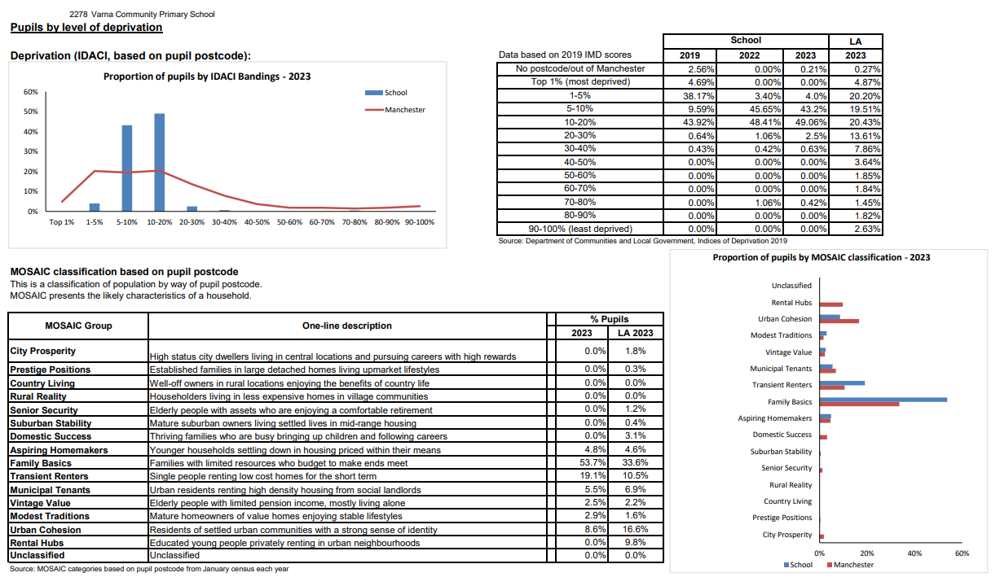

The school is situated in Openshaw, a suburb of Manchester, England, about three miles east of the city centre.
In 2019, this LSOA was ranked 1,165 out of 32,844 in England, where 1 is the most deprived LSOA. This is amongst the 10% most deprived neighbourhoods in the country.
An Indices of Deprivation Report released in 2019 by Manchester City Council found that 43% of LSOA (Lower Layer Super Output Areas) in Manchester were in the most deprived 10% of the whole country. Clayton and Openshaw was identified as the 3rd most deprived ward in Manchester.
Clayton and Openshaw was in the most deprived 10% of areas of the whole country in the following areas:
- Income deprivation
- Income deprivation affecting children
- Employment deprivation
- Health deprivation
- Education, skills and training deprivation
For all other categories – crime, barriers to housing and services and living environment – it was in the 2nd most deprived 10% in the country.
The school community is very diverse with over 40 different languages spoken at home across the school.
For the academic year 2023-2024 the school has 48% pupil premium qualifying pupils of its whole cohort.
All strategies used by the school in terms of the Pupil Premium spend for 2023-2024 have been researched and assessed using the EEF Teaching and Learning Toolkit predominantly, as well as other sources of evidence.
What are we doing this year?
- Quality First Teaching is the main driver for improvement in outcomes for PPQ children
- Targeted interventions across the school are also used to help close the gap between PPQ and non-PPQ children
- Subject leadership focus for the whole year is again centred around PPQ, SEND and EAL pupils – observations, pupil and staff voice, work scrutinies
- Before and after school tuition for PPQ pupils pupils running across the school from Spring Term
- Subject leadership cover to ensure quality first teaching across the entirety of the curriculum
- Pupil Premium Tracking Grids produced by PPQ Lead for reading, Writing and Maths for each year group.
- Weekly Meetings between class teachers and Learning Support Assistants (LSAs) to involve discussion on PPQ children – progress, barriers, interventions etc. This carries on from last year when this was introduced
- Bi-weekly case study conversation with PPQ child to begin. This will run for 6 sessions across the term. Each week will have a different focus for questions
- Pupil Progress sheets to be adapted to show tracking grid progress of PPQ children in each class. This will be prepared by PPQ lead and shared with staff before the Pupil Progress Meetings
- Pupil Progress meetings will include a case study conversation
- Pupils continue to be provided with a range of educational experiences paid for by the school

Challenges

This details the key challenges to achievement that we have identified among our disadvantaged pupils.
Challenge number | Detail of challenge
1 | Limited Language and Communication Skills on arrival to school and some still prevalent in KS1 and KS2. 41% of our EYFS cohort for 2023-2024 is EAL. See table below for entry pints for EYFS in regards to Communication and Language
2 | Low attainment on entry to the Early Years Foundation Stage, based on baseline assessments done after 6 weeks, in all areas of the EYFS Framework.  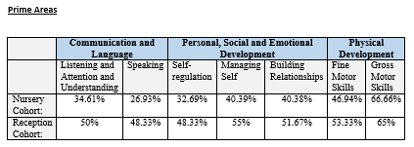  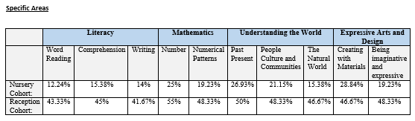
3 | Area of social deprivation means that real world experiences are often limited for the school cohort. Opportunities to develop cultural capital across the school through a programme of curriculum enrichment where learning opportunities are further enhanced in a variety of ways is essential.
4 | Additional Needs of PPQ children:  27% of disadvantaged pupils have a dual SEND need  49% of PPQ children are EAL

Intended outcomes
This explains the outcomes we are aiming for by the end of our current strategy plan, and how we will measure whether they have been achieved.
Intended outcome | Success criteria
Disadvantaged pupils maintain at least the standard of attainment they achieved at the end of the previous year (Reading, Writing and Maths) and previous key stage; those who have ‘fallen behind’ make accelerated progress and ‘catch up’ or exceed prior attainment standards. | End of summer 2024 data will show that 95 – 100% of disadvantaged children have made expected progress from the previous summer.
Disadvantaged pupils to achieve a Good Level of Development in line with National Average (67% in 2023). | Improve from 2023 level of 65% to be broadly in line with 67% at the end of the 2023-2024 academic year.
Disadvantaged pupils achieve across reading, writing and maths at the end of KS2. Case studies and close monitoring of this group across the year will be used to identify areas of need and support. | End of year outcomes show that the gap between PPQ and non-PQ children achieving the expected standard in R,W and M decreases from 2023 data:  PPQ – 55.9%  Non-PPQ – 60%
Pupils have a breadth of experiences that enable them to contextualize their learning. School will deliver an engaging, broad and varied curriculum. | Teachers and support staff will plan a wide range of visits/memorable events/experiences to inspire/enhance learning and make it memorable.  Each year group will spend allocated funding on providing memorable experience days and events which excite and enthuse children to learn across all subjects. This is incudes the 4 night residential trip offered to all Y6 pupils. The expectation from the leadership of the school is that each class experiences at least 1 educational visit each term.
Activity in this academic year
This details how we intend to spend our pupil premium (and recovery premium funding) this academic year to address the challenges listed above.

Teaching (for example, CPD, recruitment and retention)
Budgeted cost: £ 89,661
Activity | Evidence that supports this approach | Challenge number(s) addressed
Phase Leaders without class responsibility  £60,645 | Quality teaching helps every child. Experienced teachers in each Key Stage to help accelerate progress/diminish the difference between pupil premium children and others in reading/Writing and Maths by modelling lessons and supporting colleagues with planning and strategies to ensure PPQ children achieve above average progress.  Mastery approaches to reading (school’s own bespoke scheme developed over the last 5 years), writing (evolved version of The Write Stuff developed by Jane Considine) and maths (White Rose Power Maths) will support Quality First Teaching in these areas of the curriculum. Each of these schemes places a high level of focus and explanation on modelling from the class teacher and their thought process. High quality, frequent feedback is a key element of this.  Evidence:  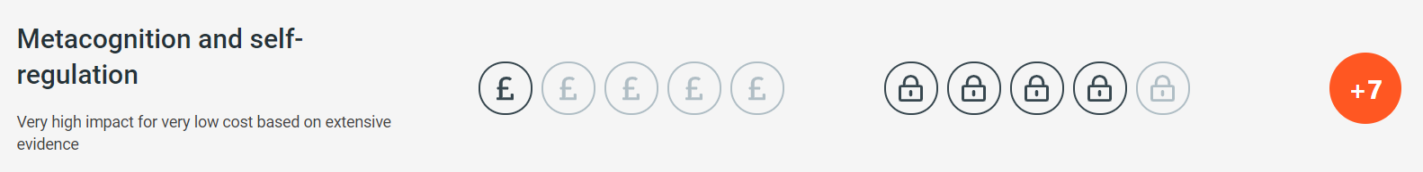  There is some evidence to suggest that disadvantaged pupils are less likely to use metacognitive and self-regulatory strategies without being explicitly taught these strategies. Explicit teaching of metacognitive and self-regulatory strategies could therefore encourage such pupils to practise and use these skills more frequently in the future. With explicit teaching and feedback, pupils are more likely to use these strategies independently and habitually, enabling them to manage their own learning and overcome challenges themselves in the future.  Mastery learning approaches aim to ensure that all pupils have mastered key concepts before moving on to the next topic – in contrast with traditional teaching methods in which pupils may be left behind, with gaps of misunderstanding widening. Mastery learning approaches could address these challenges by giving additional time and support to pupils who may have missed learning, or take longer to master new knowledge and skills.  In order for mastery approaches to be effective for pupils with gaps in understanding, it is crucial that additional support is provided. Approaches that simply build upon foundational knowledge without targeting support for pupils that fall behind are unlikely to narrow disadvantage gaps. The school uses daily interventions led by Learning Support Assistants (LSAs)s to support the mastery approach for PPQ pupils, these being same day interventions for maths and Read Write Inc.  Pupils require clear and actionable feedback to employ metacognitive strategies as they learn, as this information informs their understanding of their specific strengths and areas for improvement, thereby indicating which learning strategies have been effective for them in previously completed work. The school’s feedback and marking approach places a heavy emphasis on immediate, structured feedback.  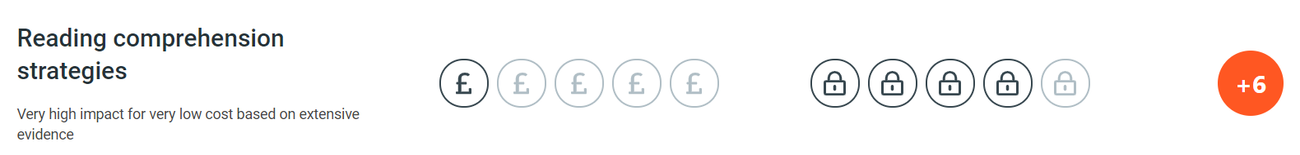  Reading comprehensions strategies involve the teaching of explicit approaches and techniques a pupil can use to improve their comprehension of written text. Many learners will develop these approaches without teacher guidance, adopting the strategies through trial and error as they look to better understand texts that challenge them. The school has achieved the One Education Gold Reading Award, in part due to its commitment to ensuring that pupils from all social backgrounds have regular access to high-quality texts both in school and to take home. | 1,2,3,4,
LSA 3 x 6 Subject Coordinator Cover 1 day per week  £29,016 | The school has employed 6 level 3 LSAs to give dedicated curriculum improvement time to subject leaders. This will allow subject leaders to see the teaching of their subjects more across the school, carry out specific book scrutinies and carry out regular pupil and staff voice. Regular reporting of strengths and areas for development across the school will lead to a further improvement in curriculum delivery.  Evidence:  Triangulation approach to subject leadership, shown below, will allow subject leaders to identify strengths and areas for development in their subject across the school.  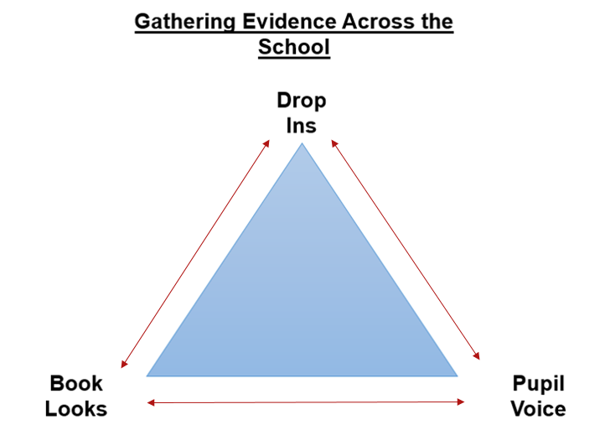  Structural-learning.com: ‘There are 3 key components to subject leadership: understanding the school context and community, a commitment to an on-going professional development in the subject and being able to discover and endorse models of change.  Juniper Education: ‘Subject leaders have three core roles:  - Judging standards of pupils’ work,  - Evaluating teaching and learning, and identifying strengths and areas for improvement,  - Leading sustainable improvement by developing a high-quality curriculum delivered through effective teaching, organising quality professional development for staff, and supporting and mentoring staff. | 1,2,3,4,

Targeted academic support (for example, tutoring, one-to-one support structured interventions)
Budgeted cost: £ 196,053
Activity | Evidence that supports this approach | Challenge number(s) addressed
3 x Additional TA 3 to support in EYFS  £86,028 | On entry to Reception, most children have low Language and Communication skills. Through daily interventions centred around language and communication, we support children with their language development from the very beginning of their time here at Varna.  Wellcom interventions 2 x per week for nursery children and NELI interventions daily for Reception children.  Last year the school did observations in every foundation subject, with PPQ and SEND children the focus for all of these. They are the focus again for subject leads this year and the observation cycle that has been completed in the autumn term (with maths as a focus) has again had a focus on PPQ and SEND children. This will continue in the spring and summer terms. Subject leads have PPQ achievement as part of their triangulation approach.  Evidence:  There is evidence to suggest that pupils from lower socioeconomic backgrounds are more likely to be behind their more advantaged counterparts in developing early language and speech skills, which may affect their school experience and learning later in their school lives. | 1,2
LSA Level 2 Targeted interventions across the school 2.5 days per week  £106,392 | Each afternoon LSAs are not class based, they deliver a range of interventions across the school. Theses cover different areas of the curriculum, as well as addressing social and emotional areas of needs:  - 1:1 daily reading  - RWInc interventions for Y2-Y6  - 1st Class @ Number  - Coloutful Semantics and handwriting  - Sensory Circuits  - Zones of Emotional Regulation  - Blanks  - Lego Therapy  Small group tuition is defined as one teacher, trained teaching assistant or tutor working with two to five pupils together in a group. This arrangement enables the teaching to focus exclusively on a small number of learners, usually in a separate classroom or working area. Intensive tuition in small groups is often provided to support lower attaining learners or those who are falling behind, but it can also be used as a more general strategy to ensure effective progress, or to teach challenging topics or skills.  Access to high quality teaching is the most important lever schools have to improve outcomes for their pupils. It is particularly important to ensure that when pupils are receiving support from a teaching assistant, this supplements teaching but does not reduce the amount of high-quality interactions they have with their classroom teacher both in and out-of-class. | 1,2,3,4
Bursary Foundation – additional support for UKS2 for entry to school requiring entrance exams  £3,633 | In 2019, only 7% of places offered at grammar schools were offered to disadvantaged pupils. By working with the Bursary Foundation, the school was supported children being offered places to disadvantage children from the school.  Evidence:  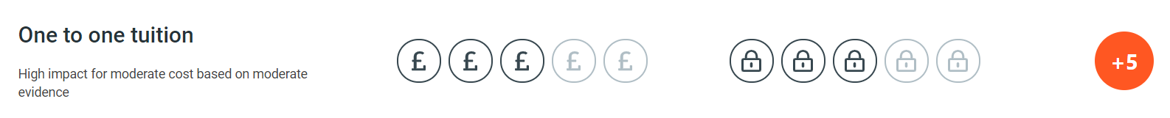  One to one tuition offers greater levels of interaction and feedback compared to whole class teaching which can support pupils spend more time on new or unfamiliar, overcome barriers to learning and increase their progress through the curriculum.  Over the past 4 years, we have had success - PPQ children put forward for the 11+ have passed it, with some going on to be offered full bursary scholarships. | 3

Wider strategies (for example, related to attendance, behaviour, wellbeing)
Budgeted cost: £ 45,500
Activity | Evidence that supports this approach | Challenge number(s) addressed
Specialist Art Teacher - supporting and developing staff to deliver quality art outcomes to improve art teaching across the school  £10,000 | Quality teaching helps every child – we are using this professional to improve the skills of our teaching staff in delivering exciting and relevant art units. Art specialist has worked with the school to create their own art curriculum for the school that is cross-curricular and meets all the expectations of the National Curriculum, as well as a sketching programme across KS1 and KS2 to help develop a range of techniques, promote mindfulness and allow the children more opportunities to be creative.  Evidence:  There is intrinsic value in teaching pupils creative and performance skills and ensuring disadvantaged pupils access a rich and stimulating arts education.  OFSTED Research Review series (February 2023): Art and design: ‘A report has highlighted a decline in both the quality and quantity of art education in primary schools. There may be a range of reasons for this, including:  - a decline in real-terms funding, so pupils have less access to specialist resources and support  - schools focus more on core subjects and less on foundation subjects  - primary teachers lack the skills, training and experience to teach a high-quality art curriculum | 1,2,3,4,
School Residential  £17,500 | The vast majority of our pupils’ only time away from home during the year is on the school residential. It is essential for their own wellbeing that they experience different settings before writing about it. The residential is linked to themes and foci that they study in school.  Adventure education usually involves collaborative learning experiences with a high level of physical (and often emotional) challenge. Practical problem-solving, explicit reflection and discussion of thinking and emotion may also be involved. The school uses Outward Bound as their provider and during the organisation stages of the trip, certain foci are used across the week based on the cohort. In the past these have been such values as cooperation and resilience.  Evidence:  Physical activity has important benefits in terms of health, wellbeing and physical development.  Business Education states, ‘In addition to the multitude of evidence, there is much anecdotal support about benefits of outdoor education experiences; teachers, for example, often speak of the improvement they have in relationships with students following a trip. School trips are an important part of the wider family of outdoor learning opportunities, all of which provide beneficial outcomes to children with a wide range of abilities and issues. | 1,3
Educational Visits  £12,000 | All young people need the knowledge, skills and understanding to live in, and contribute to, a global society and this begins with an understanding of the world in which we live, including the languages, values and cultures of different societies. For many of our pupils, this global society approach cannot be successful without first them knowing their local knowledge – educational visits help to enrich their learning and perception of the world through first-hand experiences. | 1,2,3,4,
School Gardener and outdoor learning  £6,000 | Children from Y2-6 have been attending weekly sessions to help them develop environmental understanding as well as social and emotional skills. Generally, children to choose what they would like to do, from a range of activities. The general session plan is:  - circle activity where each person says one thing they have done or enjoyed in the outdoor area  - quick exploration of the area to identify changes, work that needs to be done or opportunities  - children choose what they would like to do, staff support  - circle activity where each person says one thing they have done or enjoyed today  Evidence:  A collaborative (or cooperative) learning approach involves pupils working together on activities or learning tasks in a group small enough to ensure that everyone participates. Pupils in the group may work on separate tasks contributing to a common overall outcome, or work together on a shared task. This is distinct from unstructured group work. | 1,3,4
Family Support Worker 1 day per week  £6,435 | One day a week Family Support Worker working specifically with disadvantaged families across a whole range of issues and challenges:  - Food banks  - Housing  - Benefits  - General school level support and interventions  - White goods scheme  - No recourse to public funds families  Evidence:  Parental engagement refers to teachers and schools involving parents in supporting their children’s academic learning which includes more intensive programmes for families in crisis. | 1,2,3,4

Total budgeted cost: £ 337,649

Part B: Review of outcomes in the previous academic year

Pupil premium strategy outcomes
This details the impact that our pupil premium activity had on pupils in the 2021 to 2022 academic year.
Review of 2022-223
Positives
- The profile of PPQ children across the school increased:
- class teachers were much more aware of who the PPQ children were in their class
- LSAs were much more aware of who the PPQ children in their class were
- Observation cycles focussed on PPQ children in each term. The key foci were PPQ children in these observations were:
- Is the work set for the PPQ pupils ambitious and appropriate?
- What feedback do the PPQ children receive in class?
- Are the PPQ children actively engaging in their learning?
- Pupil voice provided from the observation cycles showed PPQ enjoy school and are engaged in their learning and were able to reflect on what they have improved on and why
- Data - Maths and Writing broadly showed that the attainment gap between PPQ and non PPQ children narrowing
- Case studies established for PPQ children across the school so we had evidence of pupil voice across the school year

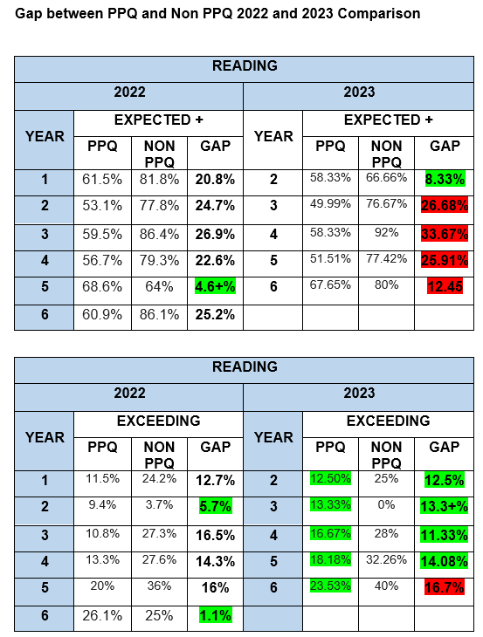

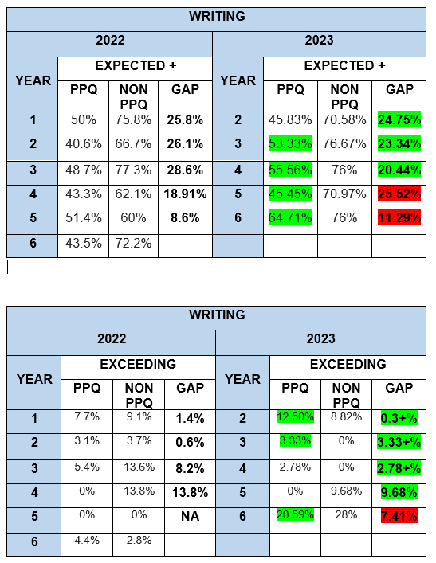
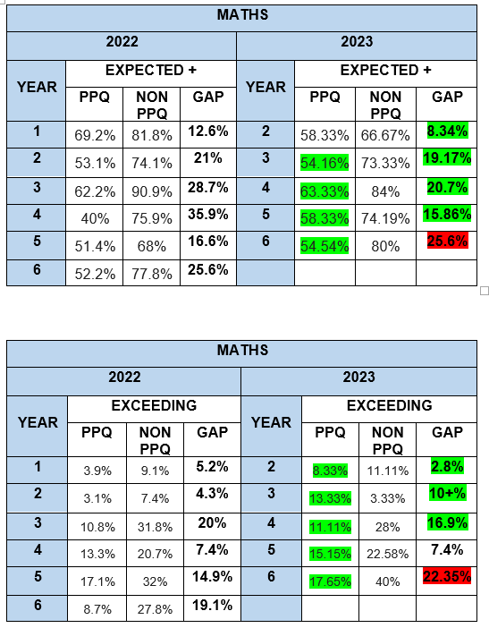

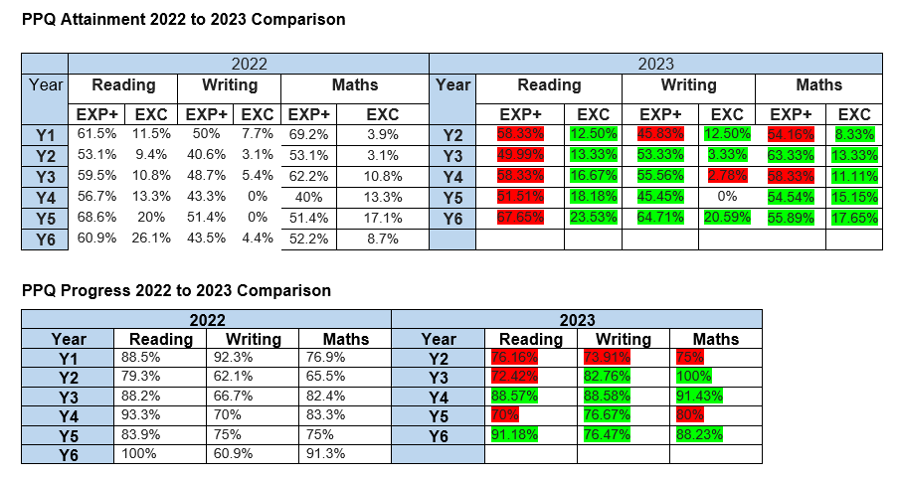
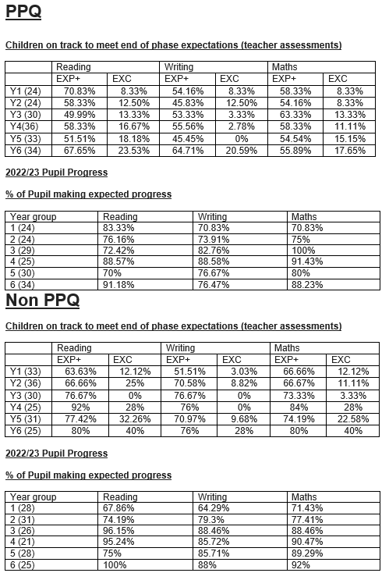

Externally provided programmes
Please include the names of any non-DfE programmes that you purchased in the previous academic year. This will help the Department for Education identify which ones are popular in England
Programme | Provider
The Literacy Shed Plus
Times Table Rockstars
Power Maths
Language Angels
Charanga
Read Write Inc.
Snap Science
Jigsaw Spiral Curriculum

Service pupil premium funding (optional)
For schools that receive this funding, you may wish to provide the following information:
Measure | Details
How did you spend your service pupil premium allocation last academic year?
What was the impact of that spending on service pupil premium eligible pupils?

Further information (optional)
Use this space to provide any further information about your pupil premium strategy. For example, about your strategy planning, or other activity that you are implementing to support disadvantaged pupils, that is not dependent on pupil premium or recovery premium funding.

